QUIZ QUESTIONS 2

Name : Evan Diantha Fafian

Class : SIB 2G

Absent : 09

NIM : 2341760163

OBJECT-BASED PROGRAMMING PRACTICUM

1. Identify the following Abstract method and Class usage, explain the purpose of the diagram class and create the program code to the demo to display it.

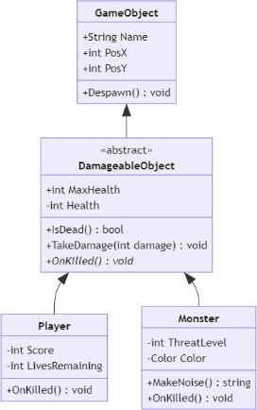

Answer :

**Diagram Explanation**

* Class GameObject

Functions: A base class that provides generic attributes and functions for objects in the game, such as Name, position (PosX, PosY), and Despawn() method.

* Abstract Class DamageableObject

Function: Represents objects that have the property of being able to take damage.This class is abstract because it has an abstract method (OnKilled) that must be implemented by its child classes. In addition, it provides MaxHealth and Health attributes, as well as methods such as IsDead() and TakeDamage().

* Class Player

Function: A player-specific derivative of DamageableObject. Adds Score and LivesRemaining attributes, and implements the OnKilled() method.

* Class Monster

Function: Derived from the enemy-specific DamageableObject. Added ThreatLevel and Color attributes, as well as additional MakeNoise() method and OnKilled() implementation.

**Program Implementation**

* GameObject

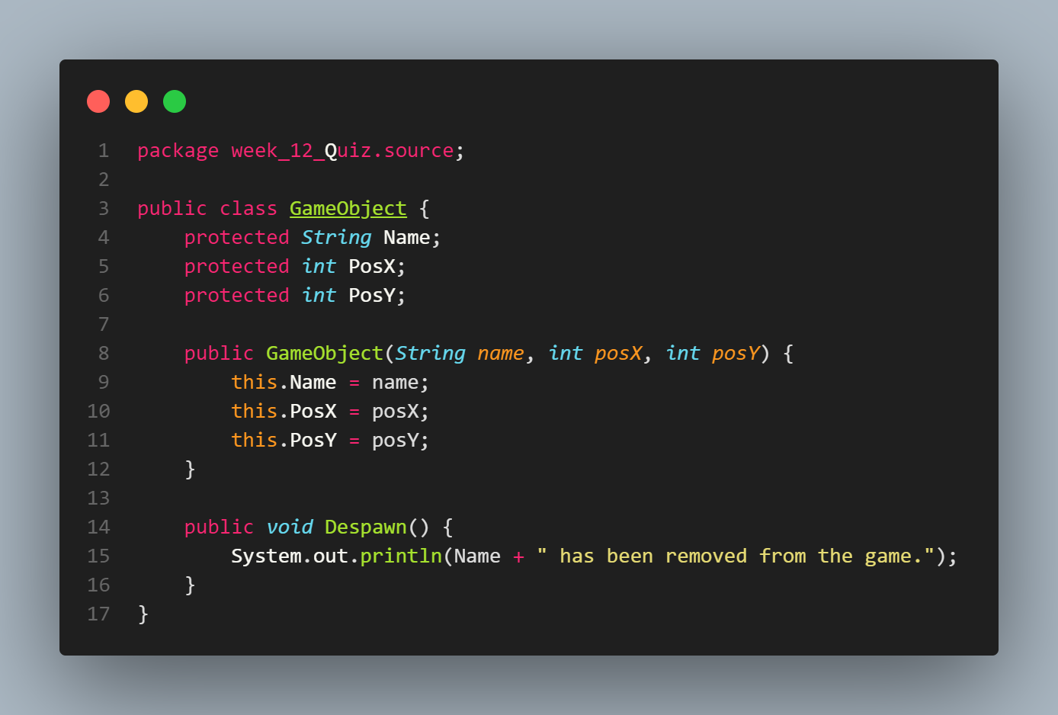

* DamageableObject

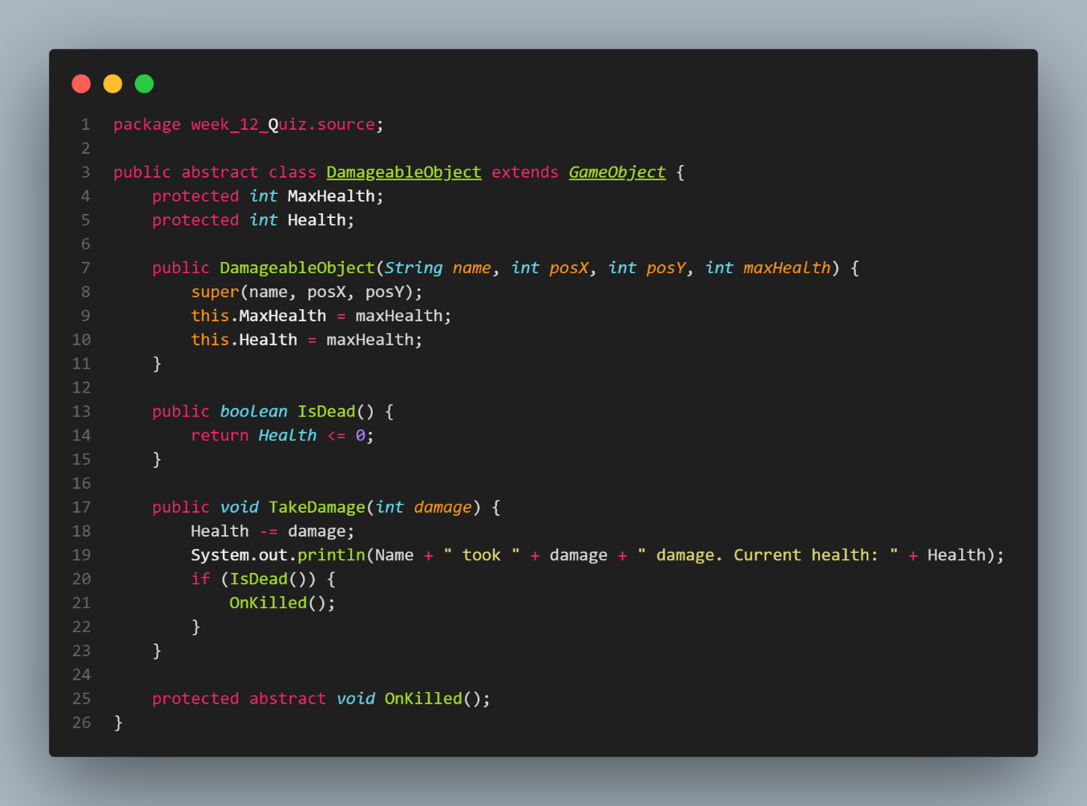

* Player

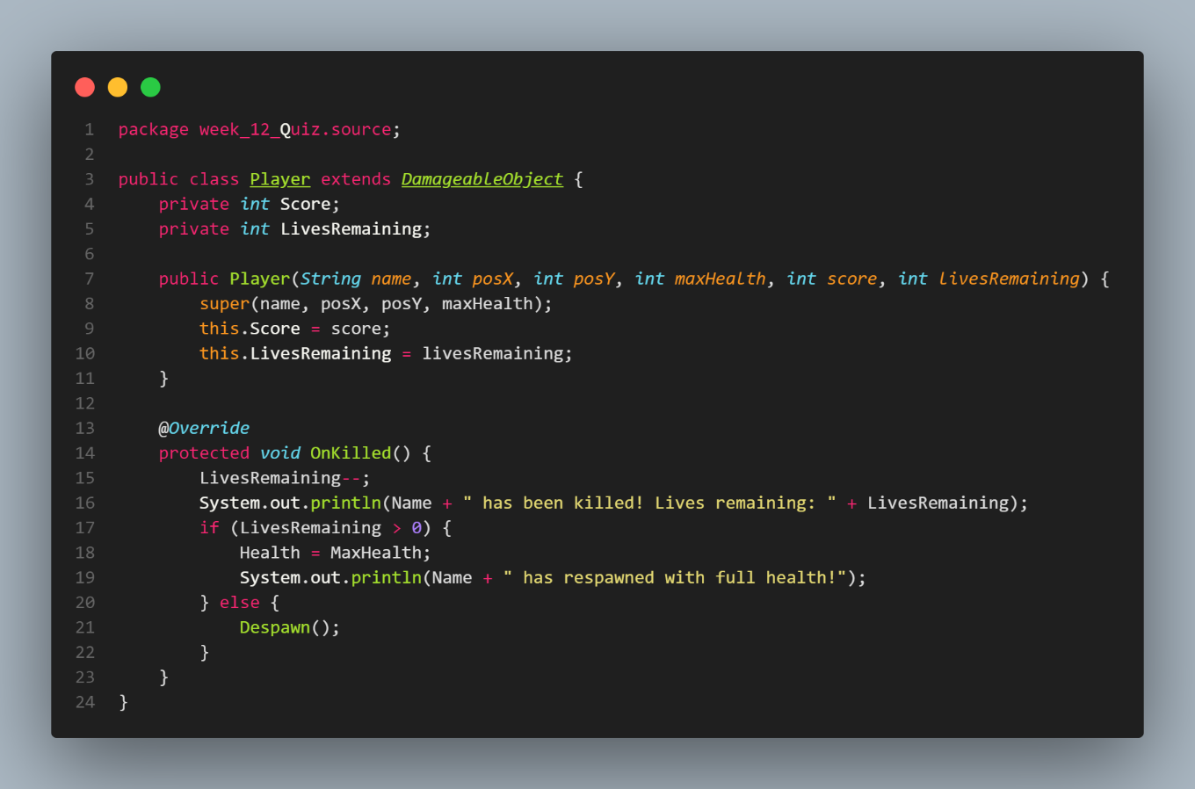

* Monster



* Main

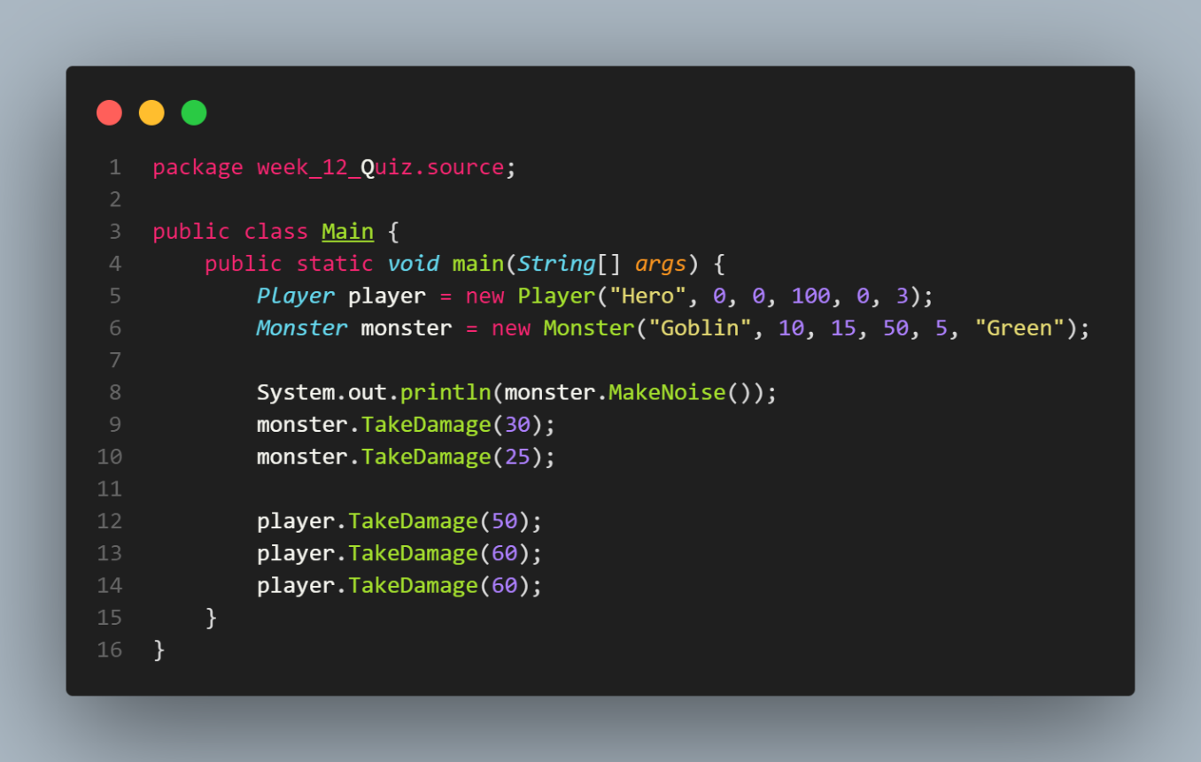

* Output

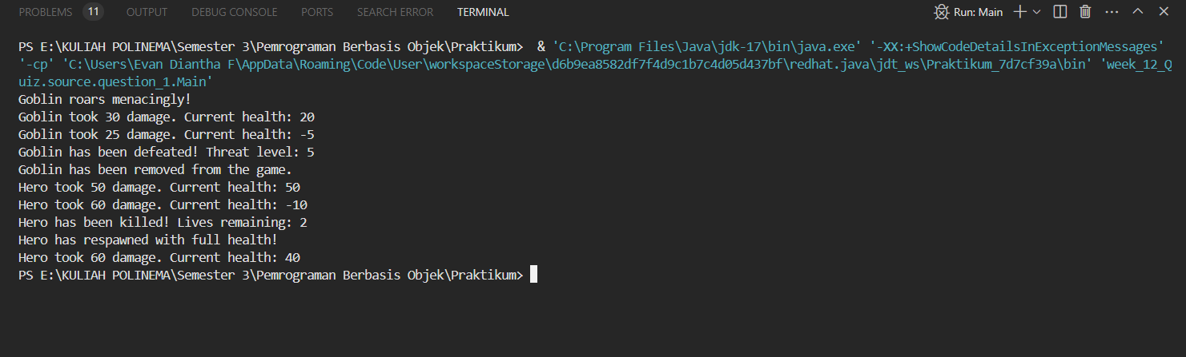

1. A client of yours is a Seller who has a lot of media to accommodate orders from customers, but this Seller has difficulty in creating Order categories, he wants every order to have an order date and there must be a confirmation method for each category which is separated into 3 classes: MailOrder, WebOrder, WhatsappOrder. There is an "order status tracking" contract on the MailOrder and WebOrder classes

Help your client by describing his diagram classes that are easy for him to understand!

Answer :

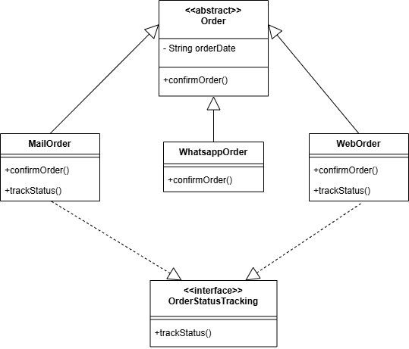

1. Give an example of program code using the concept of polymorphism (Heterogenous Collection, Object Casting, Polymorphic Arguments,

Answer:

* OfficeWorker

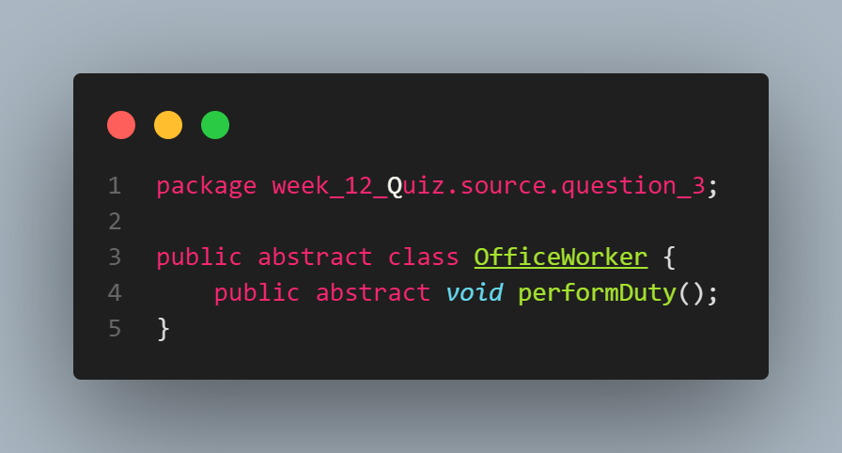

* Manager

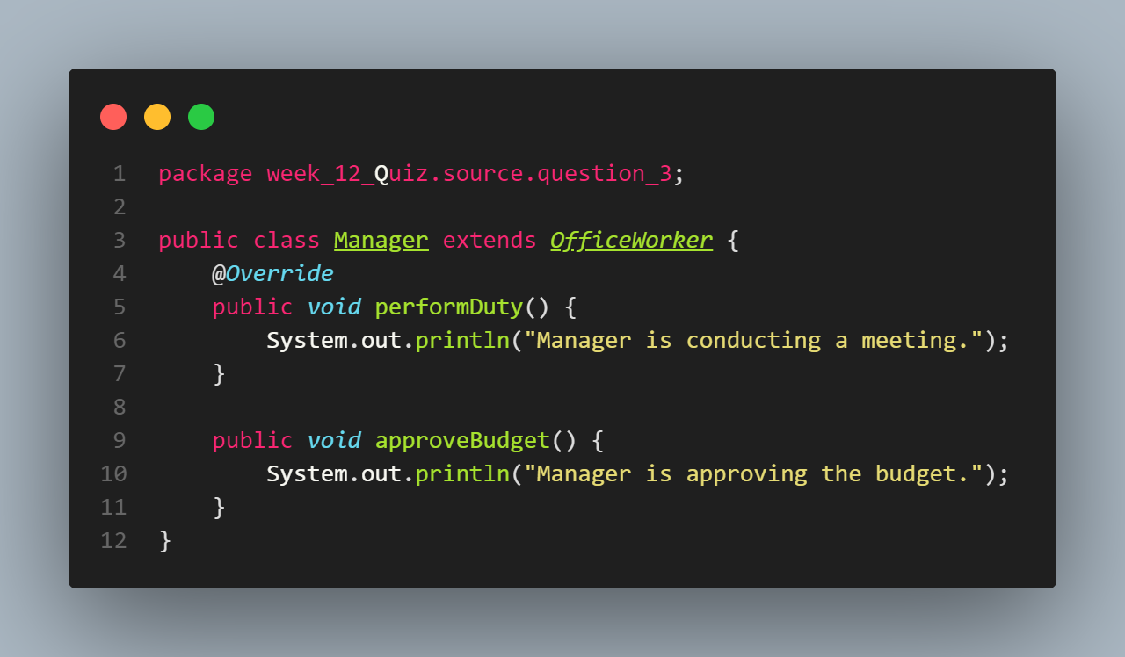

* Developer

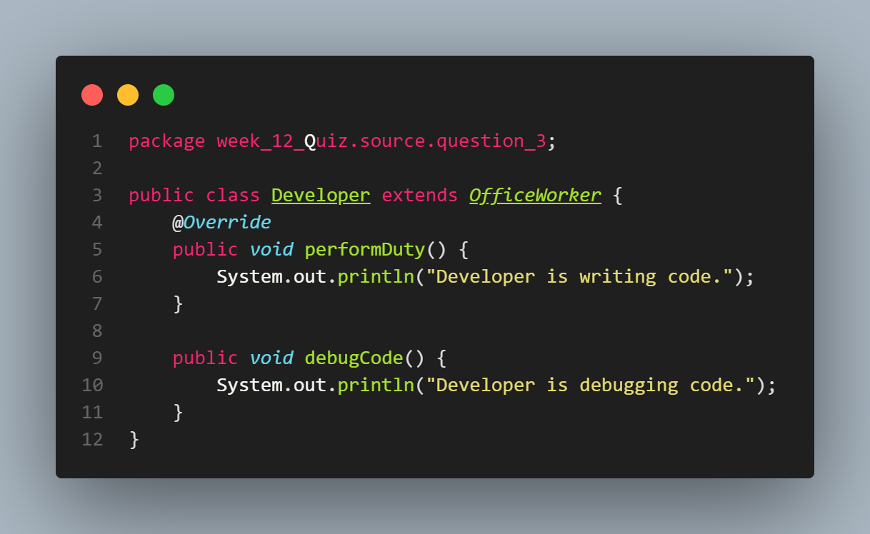

* Receptionist

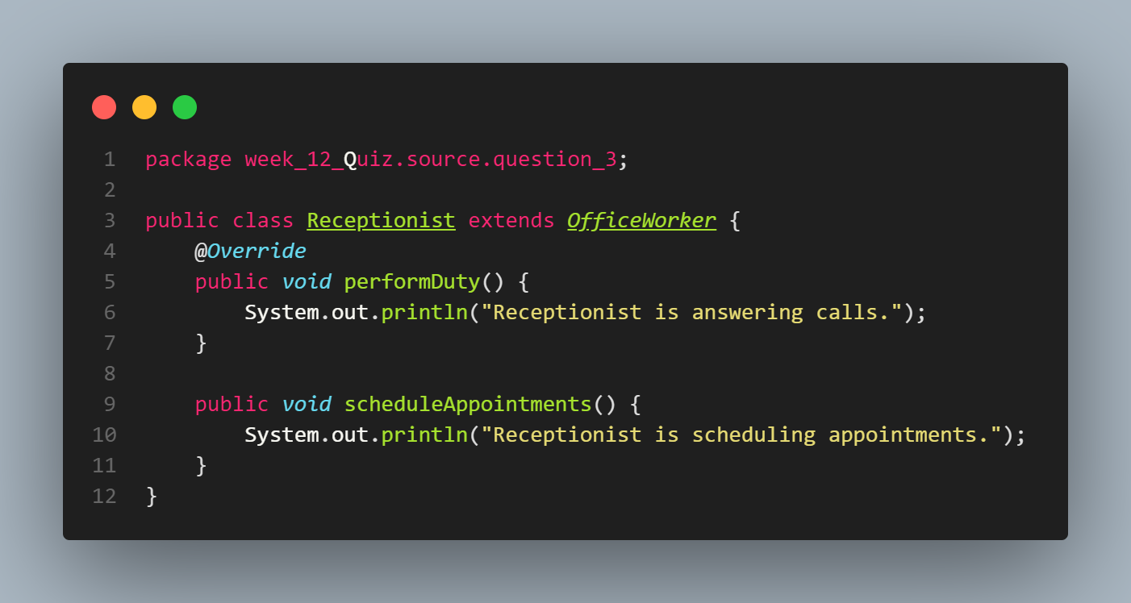

* OfficeManager

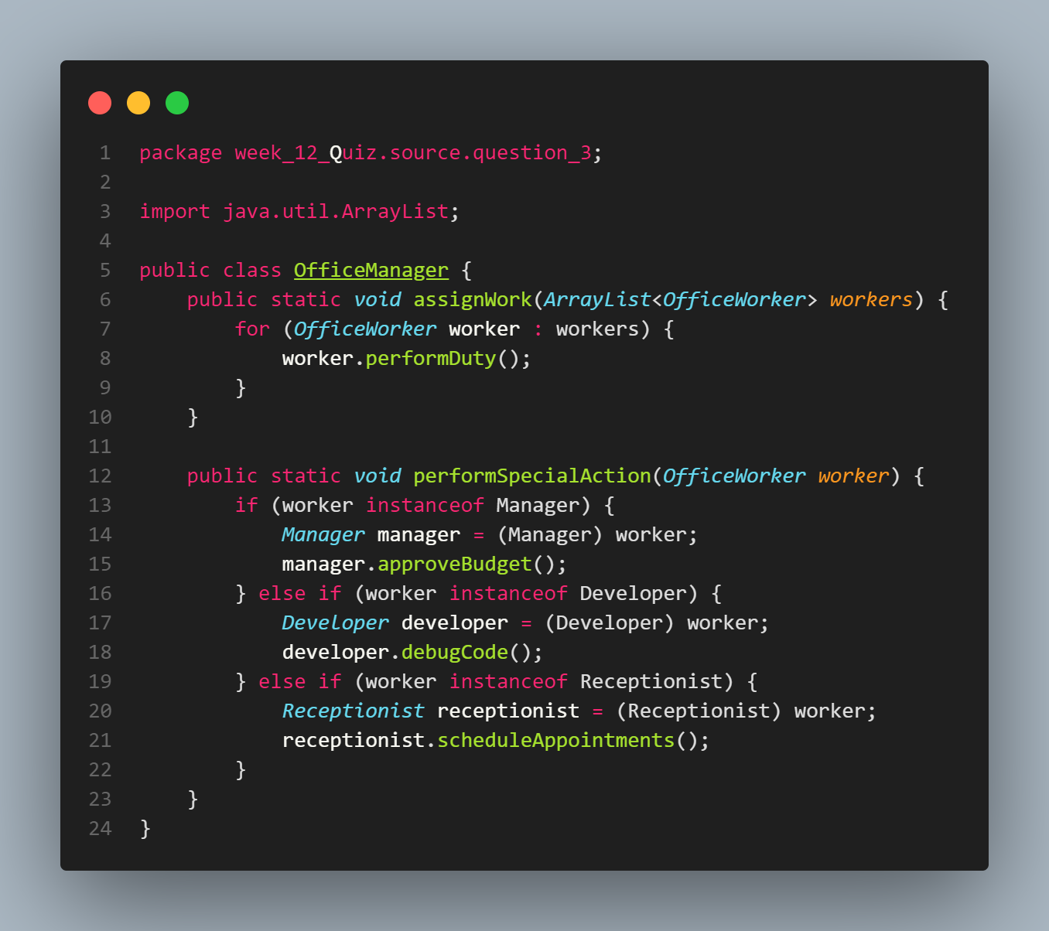

* Main

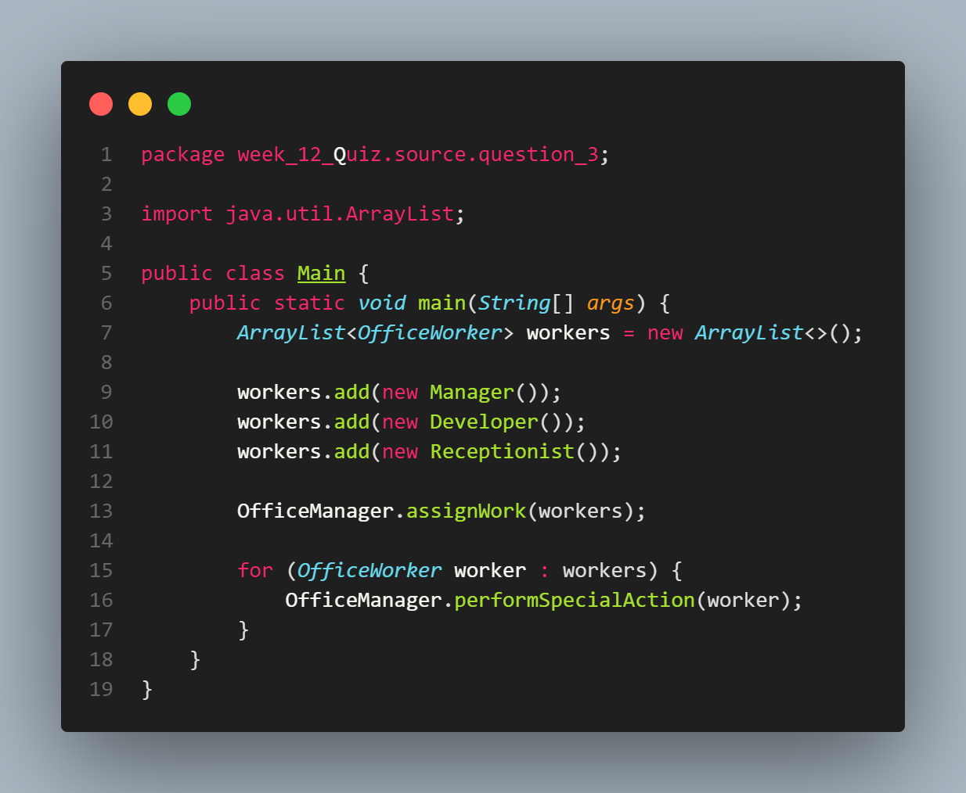

* Output

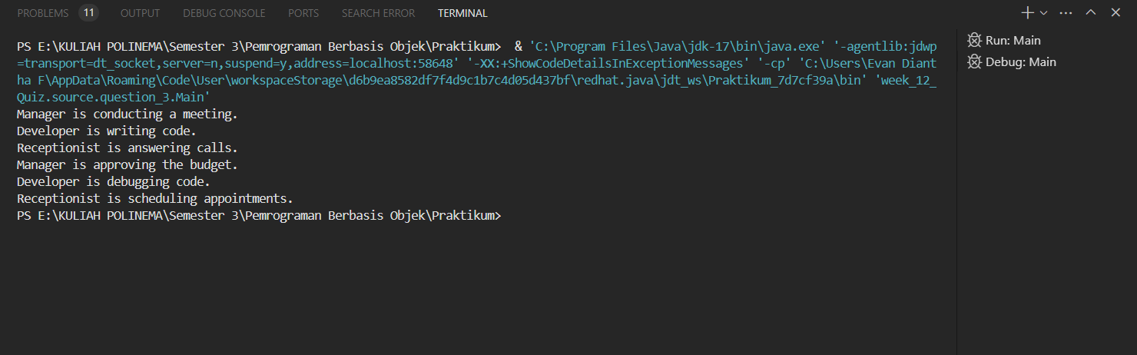

InstanceOf) on 1 theme (for example, choose 1 theme: vehicle or electronic device or animal, etc... You can create any theme to apply the 4 points of polymorphism). Create interrelated java program code.

GitHub :

<https://github.com/rankadian/PEMROGRAMAN-BERBASIS-OBJEK.git>

**---- Good Luck ----**